**Title**

AUTHOR(S)

*Microbiology Laboratory, Middlebury College, Middlebury, VT 05753 (***Address** *style)*

Received 4 December 2017/Accepted 4 December 2017(**Date received** style)

**Abstract style. Psychrophilic organisms are those organisms with low temperature growth optima (<20°C) and have been implicated in such economically important activities as the quality deterioration of frozen seafood….**

**___________________________________________________**

**INTRODUCTION[1]**

[2]Psychrophilic bacteria are those organisms with low temperature growth optima. A psychrophile…

**MATERIALS AND METHODS**

**[3]Preparation of Tissue Extracts**. Chilled haddock was minced…

**RESULTS**

text

***Tables:***

|  |  |  |  |  |
| --- | --- | --- | --- | --- |
|  |  |  |  |  |
|  |  |  |  |  |

**Table1: Results of biochemical testing…**

***Figures* :**

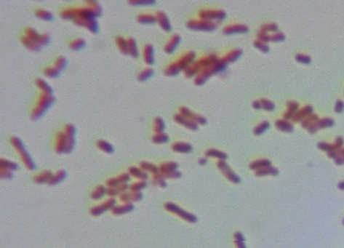

**Figure1: Gram stain of bacterial isolate….**

**DISCUSSION**

text

**ACKNOWLEDGEMENTS**

text

**LITERATURE CITED**

1. **Name.** bibliography[4]

2. **Name.** bibliography

1. **Section header** style
2. **Text** style(indents automatically—do not use tabs.)
3. **Normal** style—does not indent.
4. **Biblio** style